Assignment No-01

**Assign SQL**

Q1

1. select * from emp where sal>2000 and comm>200;
2. select * from emp where job=‘CLERK’ or sal>2000;
3. select * from emp where sal=1250 or sal=1100 or sal=2850;
4. select * from emp where sal>1250 and sal<2850;
5. select * from emp where ename like ‘%AS’;
6. select * from emp where job like ‘C%K’;
7. select * from emp where jon like ‘__L%M__’;
8. select * from emp where sal not in (1250,1100,2850);
9. select * from emp where sal not between 1250 and 2850;
10. select * from emp where REGEXP_like(job,’^C.E.*K$’);
11. select * from emp where comm is null;
12. select * from emp where sal is null and ename like ‘%S’;
13. select * from emp  where REGEXP_like(job,’^…..$’);// (job,’^.{5}$’);
14. select * from emp where REGEXP_like(ename,’^A’) and REGEXP_like(job,’^…..$’);

Q2

1. select ename,sal,deptno from emp where deptno in (20,30,40)
2. select sal,comm,ename,sal + nvl(comm,0)+sal*0.01 netsal from emp;
3. select ename,job from emp where hiredate<’01-jan-86’ and sal between 1200 and 2500;
4. select empno,ename,deptno from emp where mgr=7698;
5. select ename,job,sal,deptno from emp where deptno in (10,30);
6. select

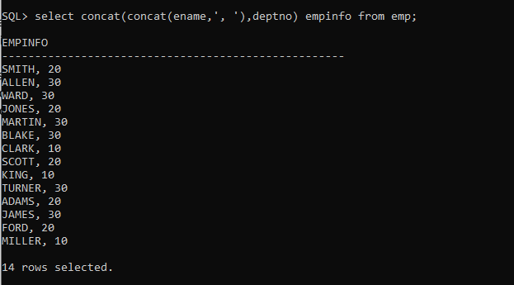

1. select * from emp where mgr is null;
2. select ename,deptno,hiredate from emp where hiredate between ’01-jan-1981’ and ’31-mar-1983’;
3. select * from emp where REGEXP_like(job,’AGE’);
4. no question
5. select * from emp where REGEXP_like(ename,’^A.*S$|^..?N.*[NS]$’);
6. select ename from emp where REGEXP_like(ename,’_+’);

Group Function

Q 1.

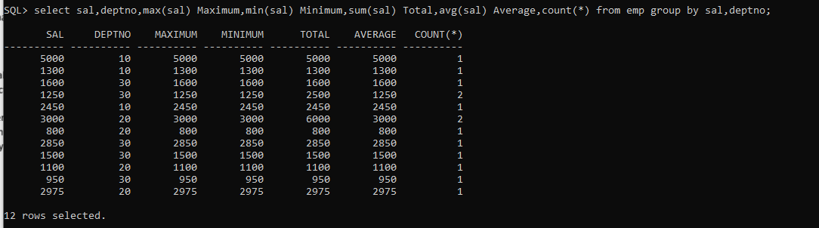

Q2.

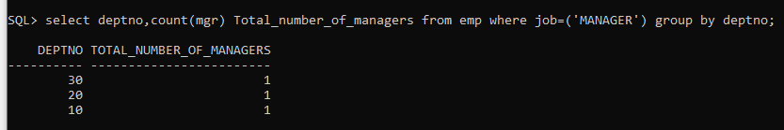

Q3.

